ACLRS Reception Staff Portal Full PHP Code
Complete PHP integration examples for all seven Reception Staff Portal screens. Each section includes secure access, database processing, prepared SQL queries, responses and error handling.

index.php
Source file: pages/staff/reception/index.php
Purpose: Checks Reception Staff access, creates the CSRF token and loads the complete Reception Staff Portal interface and supporting frontend services.
<?php
declare(strict_types=1);
require_once __DIR__ . '/../../../includes/auth.php';
$currentUser = require_receptionist();
if (empty($_SESSION['csrf_token'])) {
$_SESSION['csrf_token'] = bin2hex(random_bytes(32));
}
$receptionUser = [
'user_id' => (int)$currentUser['user_id'],
'username' => (string)($currentUser['username'] ?? 'Reception Staff'),
'email' => (string)($currentUser['email'] ?? ''),
'first_name' => (string)($currentUser['first_name'] ?? ''),
'last_name' => (string)($currentUser['last_name'] ?? ''),
];
?>
<!DOCTYPE html>
<html lang="en">
<head>
<meta charset="UTF-8">
<meta name="viewport" content="width=device-width, initial-scale=1.0">
<title>ACLRS | Reception Staff</title>
<link rel="preconnect" href="https://fonts.googleapis.com">
<link rel="preconnect" href="https://fonts.gstatic.com" crossorigin>
<link href="https://fonts.googleapis.com/css2?family=Inter:wght@400;500;600;700&display=swap" rel="stylesheet">
<link rel="stylesheet" href="https://cdnjs.cloudflare.com/ajax/libs/font-awesome/6.5.2/css/all.min.css">
<link rel="stylesheet" href="assets/css/styles.css">
<link rel="stylesheet" href="assets/css/forms.css">
<link rel="stylesheet" href="assets/css/reception.css">
<link rel="stylesheet" href="../../../css/specimen/master-portal.css">
</head>
<body>
<div class="app-container">
<aside class="sidebar" id="sidebar">
<div class="sidebar-header">
<div class="logo"><img src="../../../images/alc-logo.png" alt="Australian Clinical Labs logo"><div class="logo-text"><h1>Australian Clinical Labs</h1><span>Online Reporting System</span></div></div>
</div>
<nav class="sidebar-nav">
<ul class="nav-list">
<li class="nav-item active" data-route="dashboard"><a class="nav-link" href="#dashboard"><i class="fa-solid fa-house"></i><span>Dashboard</span></a></li>
<li class="nav-item" data-route="patient-search"><a class="nav-link" href="#patient-search"><i class="fa-solid fa-hospital-user"></i><span>Patients</span></a></li>
<li class="nav-item" data-route="appointments"><a class="nav-link" href="#appointments"><i class="fa-regular fa-calendar-check"></i><span>Appointments</span></a></li>
<li class="nav-item" data-route="requests"><a class="nav-link" href="#requests"><i class="fa-solid fa-flask"></i><span>Test Requests</span></a></li>
<li class="nav-item" data-route="referrals"><a class="nav-link" href="#referrals"><i class="fa-solid fa-file-medical"></i><span>Referrals</span></a></li>
<li class="nav-item" data-route="reports"><a class="nav-link" href="#reports"><i class="fa-solid fa-chart-column"></i><span>Reports</span></a></li>
<li class="nav-item" data-route="notifications"><a class="nav-link" href="#notifications"><i class="fa-solid fa-bell"></i><span>Notifications</span><span class="nav-badge" data-notification-count>3</span></a></li>
</ul>
</nav>
<div class="sidebar-user"><div class="avatar" data-user-initials>RS</div><div class="logo-text"><strong data-user-name>Reception Staff</strong><span data-user-email>Authorised user</span></div></div>
</aside>

<main class="main-content">
<header class="top-header">
<div class="header-left"><button class="menu-toggle" id="menuToggle"><i class="fa-solid fa-bars"></i></button><div class="breadcrumb"><span>Home</span><i class="fa-solid fa-chevron-right"></i><strong id="crumb">Reception Dashboard</strong></div></div>
<div class="header-right"><div class="global-search"><i class="fa-solid fa-magnifying-glass"></i><input id="globalSearch" placeholder="Search patients, requests..."></div><button class="icon-button" title="Notifications" data-go="notifications"><i class="fa-solid fa-bell"></i><span data-notification-dot></span></button><div class="profile-menu"><button class="profile-trigger" id="profileMenuBtn" aria-haspopup="menu" aria-expanded="false"><div class="avatar" data-user-initials>RS</div><span class="profile-summary"><strong data-user-name>Reception Staff</strong><small>Reception Portal</small></span><i class="fa-solid fa-chevron-down profile-chevron"></i></button><div class="profile-dropdown" id="profileDropdown" role="menu"><div class="profile-dropdown-head"><div class="avatar" data-user-initials>RS</div><div><strong data-user-name>Reception Staff</strong><span data-user-email>Authorised user</span></div></div><div class="profile-role"><i class="fa-solid fa-shield-halved"></i><span><small>Signed in as</small><strong>Reception Staff</strong></span></div><button type="button" id="logoutBtn" class="dropdown-logout" role="menuitem"><i class="fa-solid fa-arrow-right-from-bracket"></i><span>Log out</span></button></div></div></div>
</header>
<section id="app" class="page-content" aria-live="polite"></section>
</main>
</div>
<div id="toast" class="toast" role="status"></div>
<script>
window.ACLRS_RECEPTION_USER = <?= json_encode($receptionUser, JSON_UNESCAPED_SLASHES | JSON_HEX_TAG | JSON_HEX_AMP | JSON_HEX_APOS | JSON_HEX_QUOT) ?>;
window.ACLRS_CSRF_TOKEN = <?= json_encode($_SESSION['csrf_token'], JSON_HEX_TAG | JSON_HEX_AMP | JSON_HEX_APOS | JSON_HEX_QUOT) ?>;
</script>
<script src="assets/js/reception-store.js"></script>
<script src="assets/js/app.js"></script>
<script src="../../../shared/chatbot.js" defer></script>
</body>
</html>
1 Reception Dashboard

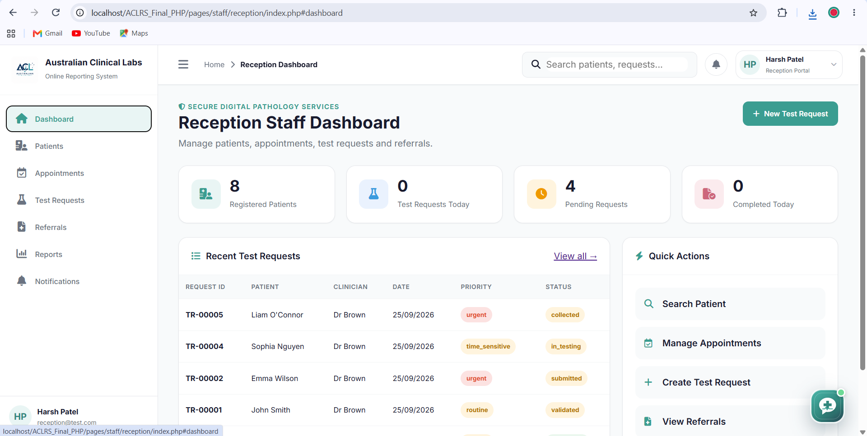
Purpose: Loads the totals and recent activity displayed on the Reception Staff dashboard.

dashboard.php
<?php
declare(strict_types=1);

require_once __DIR__ . '/../../../includes/auth.php';
$currentUser = require_receptionist();
$pdo = db();

header('Content-Type: application/json; charset=utf-8');
header('Cache-Control: no-store');

function respond(array $payload, int $status = 200): never
{
http_response_code($status);
echo json_encode($payload, JSON_UNESCAPED_SLASHES);
exit;
}

try {
$dashboard = [];

$dashboard['registered_patients'] = (int)$pdo
->query("SELECT COUNT(*) FROM patients")
->fetchColumn();

$dashboard['requests_today'] = (int)$pdo
->query("SELECT COUNT(*) FROM test_requests
WHERE DATE(requested_at) = CURDATE()")
->fetchColumn();

$dashboard['pending_requests'] = (int)$pdo
->query("SELECT COUNT(*) FROM test_requests
WHERE request_status IN
('draft','submitted','validated','collected','in_testing')")
->fetchColumn();

$dashboard['completed_today'] = (int)$pdo
->query("SELECT COUNT(*) FROM test_requests
WHERE request_status = 'completed'
AND DATE(updated_at) = CURDATE()")
->fetchColumn();

$recentStatement = $pdo->prepare(
"SELECT tr.request_id, tr.priority, tr.request_status,
tr.requested_at, p.patient_identifier,
CONCAT(p.first_name, ' ', p.last_name) AS patient_name,
CONCAT('Dr ', c.last_name) AS clinician_name
FROM test_requests tr
INNER JOIN patients p ON p.patient_id = tr.patient_id
LEFT JOIN clinicians c ON c.clinician_id = tr.clinician_id
ORDER BY tr.requested_at DESC
LIMIT 5"
);
$recentStatement->execute();
$dashboard['recent_requests'] = $recentStatement->fetchAll(PDO::FETCH_ASSOC);

respond(['ok' => true, 'dashboard' => $dashboard]);
} catch (PDOException $e) {
error_log('Reception dashboard error: ' . $e->getMessage());
respond(['ok' => false, 'message' => 'Unable to load dashboard information.'], 500);
}
?>
2 Patients Screen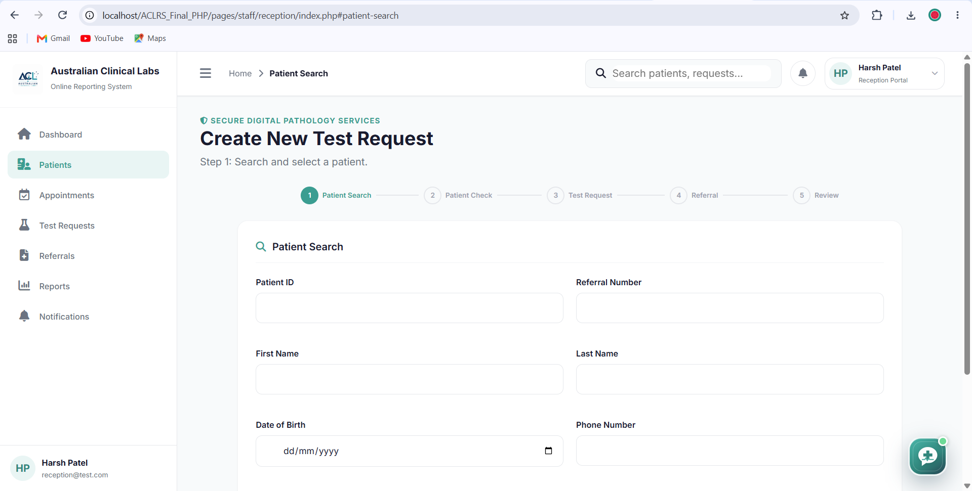
Purpose: Searches existing patients and registers a new patient when a matching record does not exist.
patients.php
<?php
declare(strict_types=1);

require_once __DIR__ . '/../../../includes/auth.php';
$currentUser = require_receptionist();
$pdo = db();

header('Content-Type: application/json; charset=utf-8');
header('Cache-Control: no-store');

function respond(array $payload, int $status = 200): never
{
http_response_code($status);
echo json_encode($payload, JSON_UNESCAPED_SLASHES);
exit;
}

try {
if ($_SERVER['REQUEST_METHOD'] === 'GET') {
$search = trim((string)($_GET['search'] ?? ''));
$statement = $pdo->prepare(
"SELECT patient_id, patient_identifier, first_name, last_name,
date_of_birth, gender, phone_number, email, address,
suburb, state, postcode, medicare_number
FROM patients
WHERE patient_identifier LIKE :search
OR first_name LIKE :search
OR last_name LIKE :search
OR phone_number LIKE :search
ORDER BY created_at DESC
LIMIT 100"
);
$statement->execute([':search' => '%' . $search . '%']);
respond(['ok' => true, 'patients' => $statement->fetchAll(PDO::FETCH_ASSOC)]);
}

$body = json_decode(file_get_contents('php://input'), true, 512, JSON_THROW_ON_ERROR);
$required = ['first_name','last_name','date_of_birth','gender','phone_number'];
foreach ($required as $field) {
if (trim((string)($body[$field] ?? '')) === '') {
respond(['ok' => false, 'message' => "$field is required."], 422);
}
}

$statement = $pdo->prepare(
"INSERT INTO patients
(first_name,last_name,date_of_birth,gender,phone_number,email,
address,suburb,state,postcode,medicare_number,created_at,updated_at)
VALUES
(:first_name,:last_name,:date_of_birth,:gender,:phone_number,:email,
:address,:suburb,:state,:postcode,:medicare_number,NOW(),NOW())"
);
$statement->execute([
':first_name' => trim($body['first_name']),
':last_name' => trim($body['last_name']),
':date_of_birth' => $body['date_of_birth'],
':gender' => $body['gender'],
':phone_number' => $body['phone_number'],
':email' => $body['email'] ?? null,
':address' => $body['address'] ?? null,
':suburb' => $body['suburb'] ?? null,
':state' => $body['state'] ?? null,
':postcode' => $body['postcode'] ?? null,
':medicare_number' => $body['medicare_number'] ?? null
]);

$patientId = (int)$pdo->lastInsertId();
$identifier = 'P' . str_pad((string)$patientId, 5, '0', STR_PAD_LEFT);
$pdo->prepare("UPDATE patients SET patient_identifier=:identifier
WHERE patient_id=:id")
->execute([':identifier'=>$identifier, ':id'=>$patientId]);

respond(['ok'=>true,'patient_id'=>$patientId,'patient_identifier'=>$identifier], 201);
} catch (Throwable $e) {
error_log('Reception patient error: ' . $e->getMessage());
respond(['ok'=>false,'message'=>'Unable to complete the patient request.'],500);
}
?>
3 Appointments Screen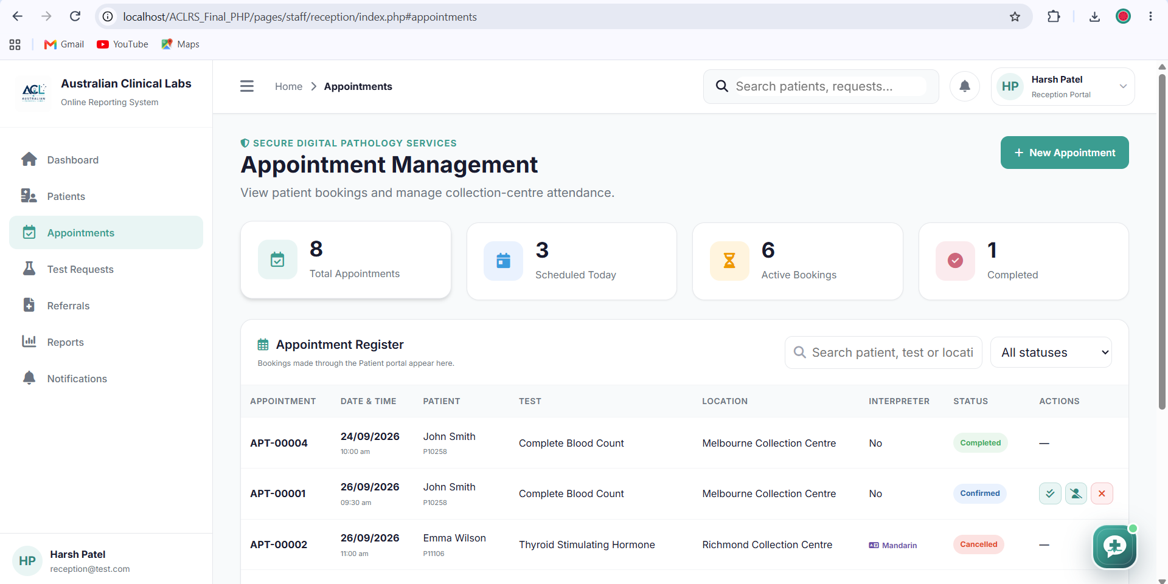
Purpose: Loads appointments, creates new bookings and updates an appointment status.
appointments.php
<?php
declare(strict_types=1);

require_once __DIR__ . '/../../../includes/auth.php';
$currentUser = require_receptionist();
$pdo = db();

header('Content-Type: application/json; charset=utf-8');
header('Cache-Control: no-store');

function respond(array $payload, int $status = 200): never
{
http_response_code($status);
echo json_encode($payload, JSON_UNESCAPED_SLASHES);
exit;
}

try {
if ($_SERVER['REQUEST_METHOD'] === 'GET') {
$statement = $pdo->query(
"SELECT a.*, p.patient_identifier,
CONCAT(p.first_name, ' ', p.last_name) AS patient_name,
t.test_name
FROM appointments a
INNER JOIN patients p ON p.patient_id = a.patient_id
LEFT JOIN test_catalogue t ON t.test_id = a.test_id
ORDER BY a.appointment_datetime DESC LIMIT 500"
);
respond(['ok'=>true,'appointments'=>$statement->fetchAll(PDO::FETCH_ASSOC)]);
}

$body = json_decode(file_get_contents('php://input'), true, 512, JSON_THROW_ON_ERROR);
$action = (string)($body['action'] ?? 'create');

if ($action === 'create') {
$statement = $pdo->prepare(
"INSERT INTO appointments
(patient_id,test_id,appointment_datetime,location,
appointment_status,special_instructions,interpreter_required,
interpreter_language,created_at,updated_at)
VALUES
(:patient,:test,:appointment_datetime,:location,'booked',
:instructions,:interpreter_required,:interpreter_language,NOW(),NOW())"
);
$statement->execute([
':patient'=>(int)$body['patient_id'],
':test'=>(int)$body['test_id'],
':appointment_datetime'=>$body['appointment_datetime'],
':location'=>trim((string)$body['location']),
':instructions'=>$body['special_instructions'] ?? null,
':interpreter_required'=>!empty($body['interpreter_required']) ? 1 : 0,
':interpreter_language'=>$body['interpreter_language'] ?? null
]);
respond(['ok'=>true,'appointment_id'=>(int)$pdo->lastInsertId()],201);
}

$allowedStatus=['booked','confirmed','rescheduled','completed','cancelled','no_show'];
$status=(string)($body['appointment_status'] ?? '');
if (!in_array($status,$allowedStatus,true)) {
respond(['ok'=>false,'message'=>'Invalid appointment status.'],422);
}
$statement=$pdo->prepare(
"UPDATE appointments SET appointment_status=:status, updated_at=NOW()
WHERE appointment_id=:id"
);
$statement->execute([':status'=>$status,':id'=>(int)$body['appointment_id']]);
respond(['ok'=>true,'message'=>'Appointment updated successfully.']);
} catch (Throwable $e) {
error_log('Reception appointment error: '.$e->getMessage());
respond(['ok'=>false,'message'=>'Unable to complete the appointment request.'],500);
}
?>
4 Test Requests Screen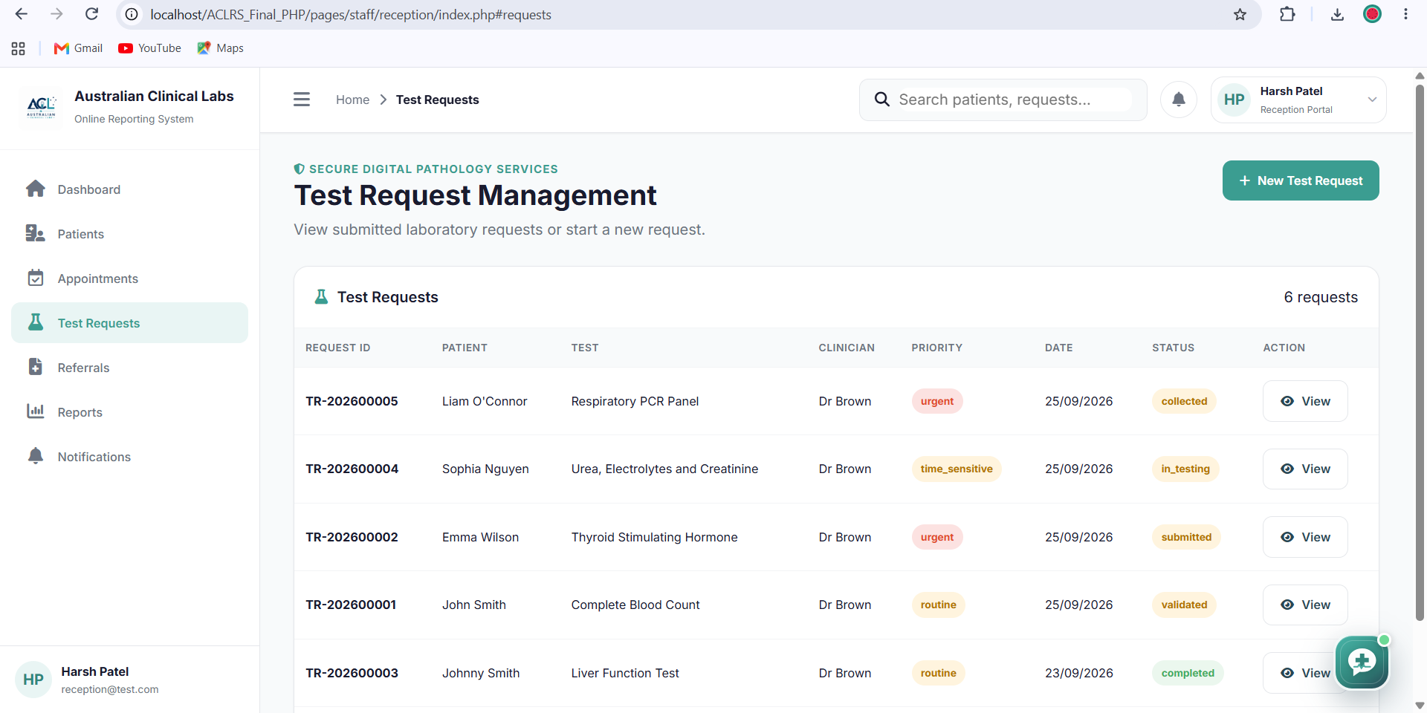
Purpose: Creates the referral, test request and request item together using a database transaction.
test_requests.php
<?php
declare(strict_types=1);

require_once __DIR__ . '/../../../includes/auth.php';
$currentUser = require_receptionist();
$pdo = db();

header('Content-Type: application/json; charset=utf-8');
header('Cache-Control: no-store');

function respond(array $payload, int $status = 200): never
{
http_response_code($status);
echo json_encode($payload, JSON_UNESCAPED_SLASHES);
exit;
}

try {
$body = json_decode(file_get_contents('php://input'), true, 512, JSON_THROW_ON_ERROR);
$patientId=(int)($body['patient_id'] ?? 0);
$clinicianId=(int)($body['clinician_id'] ?? 0);
$testId=(int)($body['test_id'] ?? 0);
$referralNumber=trim((string)($body['referral_number'] ?? ''));
$priority=(string)($body['priority'] ?? 'routine');

if (!$patientId || !$clinicianId || !$testId || $referralNumber==='') {
respond(['ok'=>false,'message'=>'Patient, clinician, test and referral number are required.'],422);
}
if (!in_array($priority,['routine','urgent','critical','time_sensitive'],true)) {
$priority='routine';
}

$pdo->beginTransaction();

$referral=$pdo->prepare(
"INSERT INTO referrals
(patient_id,clinician_id,referral_number,clinical_notes,
provisional_diagnosis,medication_info,priority,created_at)
VALUES
(:patient,:clinician,:number,:notes,:diagnosis,:medication,:priority,NOW())"
);
$referral->execute([
':patient'=>$patientId, ':clinician'=>$clinicianId,
':number'=>$referralNumber, ':notes'=>$body['clinical_notes'] ?? null,
':diagnosis'=>$body['provisional_diagnosis'] ?? null,
':medication'=>$body['medication_info'] ?? null, ':priority'=>$priority
]);
$referralId=(int)$pdo->lastInsertId();

$request=$pdo->prepare(
"INSERT INTO test_requests
(patient_id,clinician_id,requested_by_user_id,referral_id,
priority,request_status,clinical_notes,provisional_diagnosis,
medication_info,requested_at,updated_at)
VALUES
(:patient,:clinician,:user,:referral,:priority,'submitted',
:notes,:diagnosis,:medication,NOW(),NOW())"
);
$request->execute([
':patient'=>$patientId, ':clinician'=>$clinicianId,
':user'=>(int)$currentUser['user_id'], ':referral'=>$referralId,
':priority'=>$priority, ':notes'=>$body['clinical_notes'] ?? null,
':diagnosis'=>$body['provisional_diagnosis'] ?? null,
':medication'=>$body['medication_info'] ?? null
]);
$requestId=(int)$pdo->lastInsertId();

$item=$pdo->prepare(
"INSERT INTO test_request_items
(request_id,test_id,item_status,special_instructions,created_at)
VALUES (:request,:test,'requested',:instructions,NOW())"
);
$item->execute([
':request'=>$requestId, ':test'=>$testId,
':instructions'=>$body['special_instructions'] ?? null
]);

$pdo->commit();
respond(['ok'=>true,'referral_id'=>$referralId,'request_id'=>$requestId],201);
} catch (Throwable $e) {
if ($pdo->inTransaction()) $pdo->rollBack();
error_log('Reception request error: '.$e->getMessage());
respond(['ok'=>false,'message'=>'Unable to create the test request.'],500);
}
?>
5 Referrals Screen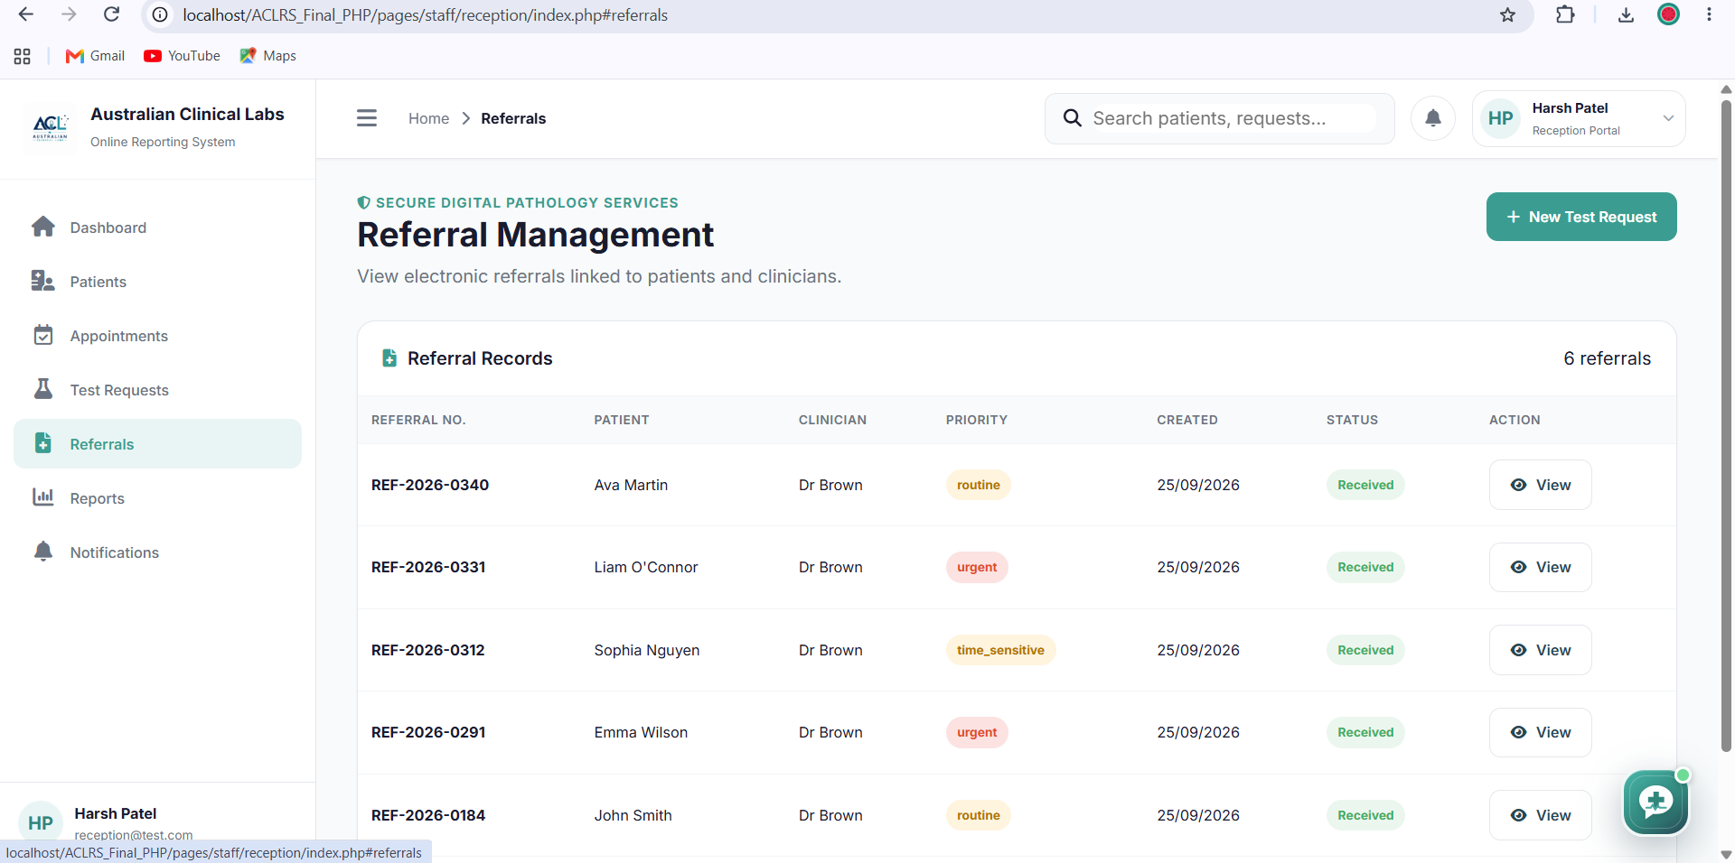
Purpose: Loads referral records with the connected patient and clinician details.
referrals.php
<?php
declare(strict_types=1);

require_once __DIR__ . '/../../../includes/auth.php';
$currentUser = require_receptionist();
$pdo = db();

header('Content-Type: application/json; charset=utf-8');
header('Cache-Control: no-store');

function respond(array $payload, int $status = 200): never
{
http_response_code($status);
echo json_encode($payload, JSON_UNESCAPED_SLASHES);
exit;
}

try {
$priority=trim((string)($_GET['priority'] ?? ''));
$sql="SELECT r.referral_id, r.referral_number, r.priority,
r.clinical_notes, r.provisional_diagnosis,
r.medication_info, r.created_at,
p.patient_identifier,
CONCAT(p.first_name, ' ', p.last_name) AS patient_name,
CONCAT('Dr ', c.first_name, ' ', c.last_name) AS clinician_name,
c.organisation
FROM referrals r
INNER JOIN patients p ON p.patient_id=r.patient_id
LEFT JOIN clinicians c ON c.clinician_id=r.clinician_id";

$params=[];
if ($priority!=='') {
$sql.=" WHERE r.priority=:priority";
$params[':priority']=$priority;
}
$sql.=" ORDER BY r.created_at DESC LIMIT 500";

$statement=$pdo->prepare($sql);
$statement->execute($params);
$referrals=$statement->fetchAll(PDO::FETCH_ASSOC);

respond(['ok'=>true,'referrals'=>$referrals]);
} catch (PDOException $e) {
error_log('Reception referral error: '.$e->getMessage());
respond(['ok'=>false,'message'=>'Unable to load referral records.'],500);
}
?>
6 Reports Screen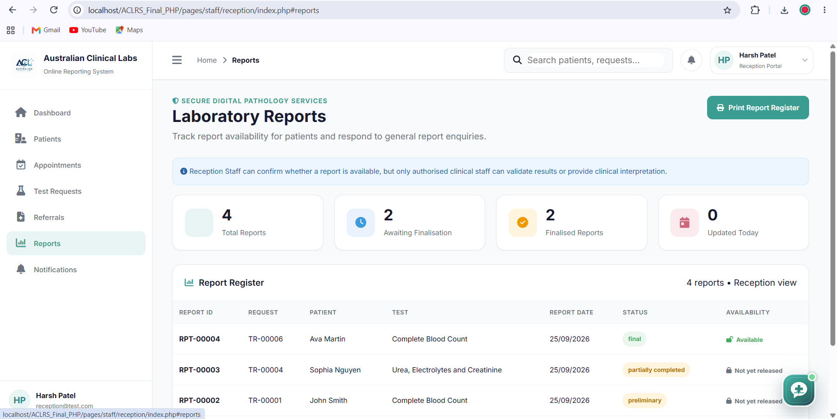
Purpose: Loads the report register and identifies whether each report is available to the patient.
reports.php
<?php
declare(strict_types=1);

require_once __DIR__ . '/../../../includes/auth.php';
$currentUser = require_receptionist();
$pdo = db();

header('Content-Type: application/json; charset=utf-8');
header('Cache-Control: no-store');

function respond(array $payload, int $status = 200): never
{
http_response_code($status);
echo json_encode($payload, JSON_UNESCAPED_SLASHES);
exit;
}

try {
$statement=$pdo->prepare(
"SELECT lr.report_id, lr.request_id, lr.report_date,
lr.report_status, lr.report_file, lr.created_at,
p.patient_identifier,
CONCAT(p.first_name, ' ', p.last_name) AS patient_name,
tc.test_code, tc.test_name
FROM lab_reports lr
INNER JOIN test_requests tr ON tr.request_id=lr.request_id
INNER JOIN patients p ON p.patient_id=tr.patient_id
LEFT JOIN test_request_items tri ON tri.request_id=tr.request_id
LEFT JOIN test_catalogue tc ON tc.test_id=tri.test_id
ORDER BY COALESCE(lr.report_date,lr.created_at) DESC
LIMIT 500"
);
$statement->execute();
$reports=$statement->fetchAll(PDO::FETCH_ASSOC);

$finalStatuses=['final','corrected','amended'];
foreach ($reports as &$report) {
$report['available']=in_array(
(string)$report['report_status'],
$finalStatuses,
true
);
}
unset($report);

respond(['ok'=>true,'reports'=>$reports]);
} catch (PDOException $e) {
error_log('Reception report error: '.$e->getMessage());
respond(['ok'=>false,'message'=>'Unable to load laboratory reports.'],500);
}
?>
7 Notifications Screen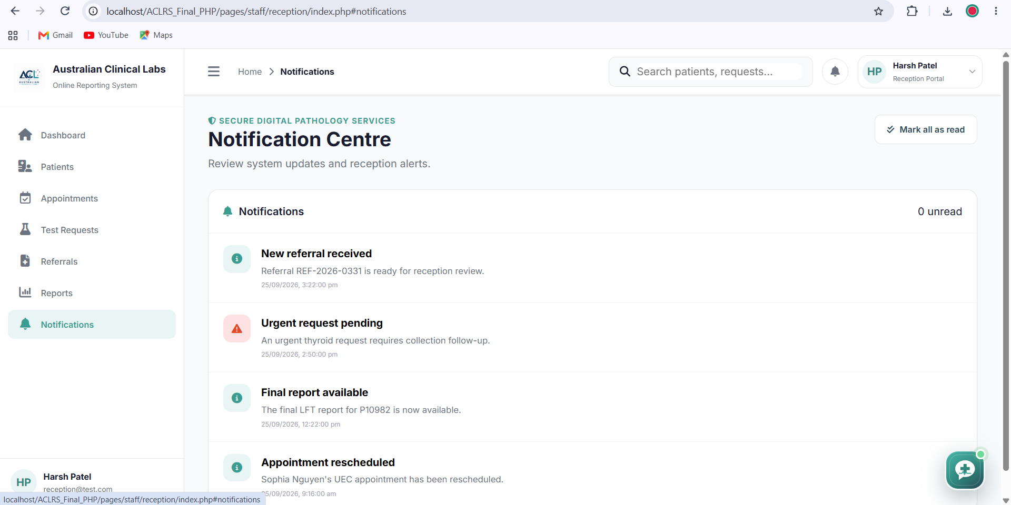
Purpose: Loads the receptionist notifications and securely marks selected notifications as read.
notifications.php
<?php
declare(strict_types=1);

require_once __DIR__ . '/../../../includes/auth.php';
$currentUser = require_receptionist();
$pdo = db();

header('Content-Type: application/json; charset=utf-8');
header('Cache-Control: no-store');

function respond(array $payload, int $status = 200): never
{
http_response_code($status);
echo json_encode($payload, JSON_UNESCAPED_SLASHES);
exit;
}

try {
$userId=(int)$currentUser['user_id'];

if ($_SERVER['REQUEST_METHOD']==='GET') {
$statement=$pdo->prepare(
"SELECT notification_id, notification_type, title, message,
priority, notification_status, is_read, created_at, read_at
FROM notifications
WHERE user_id=:user_id
ORDER BY created_at DESC
LIMIT 200"
);
$statement->execute([':user_id'=>$userId]);
respond(['ok'=>true,'notifications'=>$statement->fetchAll(PDO::FETCH_ASSOC)]);
}

$body=json_decode(file_get_contents('php://input'),true,512,JSON_THROW_ON_ERROR);
$notificationId=(int)($body['notification_id'] ?? 0);
if (!$notificationId) {
respond(['ok'=>false,'message'=>'Notification ID is required.'],422);
}

$check=$pdo->prepare(
"SELECT COUNT(*) FROM notifications
WHERE notification_id=:id AND user_id=:user_id"
);
$check->execute([':id'=>$notificationId,':user_id'=>$userId]);
if (!(int)$check->fetchColumn()) {
respond(['ok'=>false,'message'=>'Notification not found.'],404);
}

$update=$pdo->prepare(
"UPDATE notifications
SET is_read=1, read_at=NOW()
WHERE notification_id=:id AND user_id=:user_id"
);
$update->execute([':id'=>$notificationId,':user_id'=>$userId]);
respond(['ok'=>true,'message'=>'Notification marked as read.']);
} catch (Throwable $e) {
error_log('Reception notification error: '.$e->getMessage());
respond(['ok'=>false,'message'=>'Unable to update the notification.'],500);
}
?>

